ACCNET.org SharePoint Guide

January 12, 2015

Contents

Calendar 3

SharePoint

Site Actions
The Site Actions button will only be visible when the user is logged in as an administrator. We will only use the highlighted links.
- Edit Page
- Sync to SharePoint Workspace
- New Page
- New Document Library
- New Site
- More Options…
- View All Site Content
- Edit in SharePoint Designer
- Site Permissions: This is for the permissioning of the site
- Site Settings: This goes to the sites settings

Edit Page
This is to edit the current page you are on. All pages are located in the Pages document library and require check out before editing. After page edits have been completed, go to the Pages library, hover over the page name then click Check In in the drop down menu.
If you decide not to keep the edits, click Discard Check Out. Checked out pages will be indicated with a green box with an arrow pointing down:

View All Site Content
This is to view the document libraries, lists, and subsites of the site you are currently in. Here you can also create new libraries, lists, subsites, and pages.

Document Libraries
A document library is a library where documents, pages, assets, etc. are stored. These are physical objects.
To create a document library click the Create button

Then filter by Library
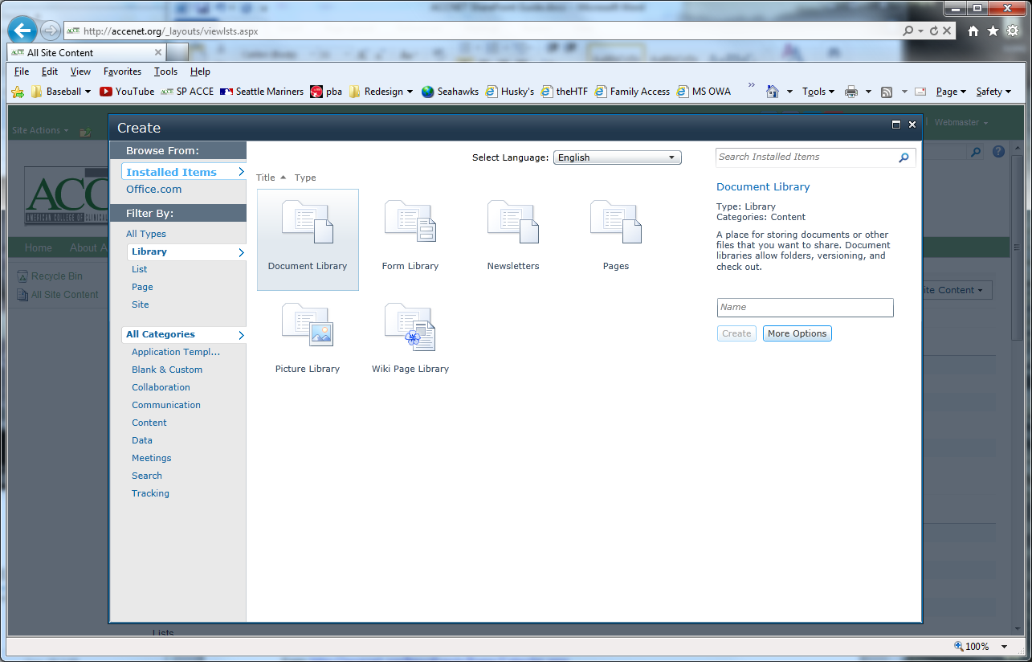
We will only be using document libraries and picture libraries. A picture library is a special kind of document library as it comes equipped with thumbnail previews and a tool to edit pictures.

Uploading Pictures

Editing Pictures
Once you have uploaded your picture, check the box next to the picture you wish to edit then click the Actions button > Edit
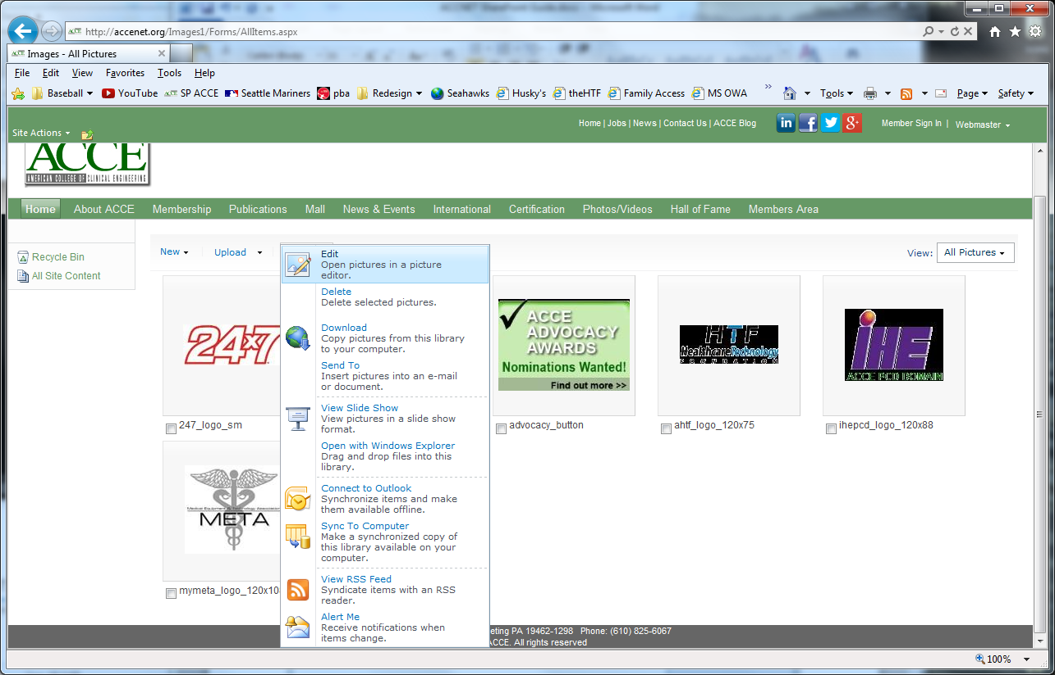
There may be a few popup messages and security check(s). Enter your password or allow content to access the tool.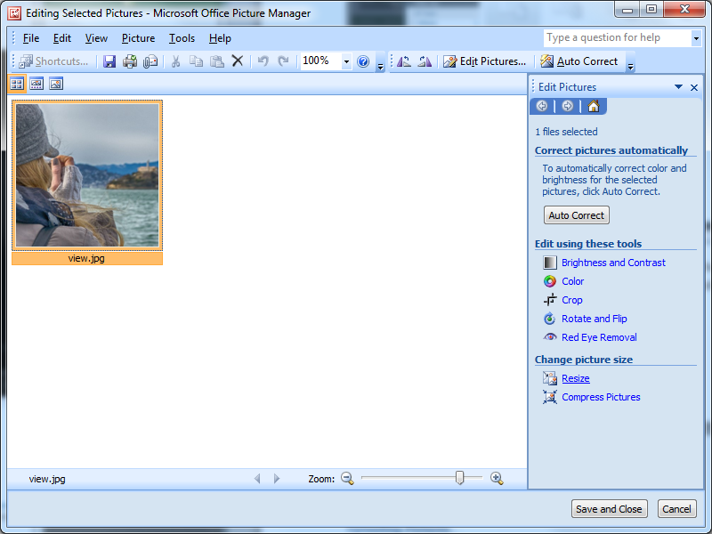
There are several tools to modify your picture. Once you are satisfied with your modifications, click Save and Close

Calendar
Page: http://accenet.org/NewsEvents/Pages/Calendar.aspx
The Schedule of Events is list driven. Only events today and greater are displayed in the schedule. Teleconferences/Webinars are denoted with the telephone icon ().
List Location: Site Actions > View All Site Content > Calendar.
Views: Calendar, All Events, Current Events
List Fields:
- Attendees: not used
- Check Double Booking: not used
- Description: event description
- End Time: end time
- Event Type:
- Faculty/Speaker
- Free/Busy
- Location
- Resources
- Sale
- Start Time
- Title
- URL

